Computational Neuroscience Workshop - EEG and Eye tracker Project Statement

Computational Clinical Psychology Shahar Lab

Maya Adar and Shaked Aglamaz

The project goal is to implement a simple BCI interface system (python tool) that will be later used in the lab for running experiments. The system will include as an input EGG and Eye tracking data (both in the form of time series data). These data streams will be encoded via signal processing techniques and decoded by a machine learning classification algorithm. The output of the system will be inferences in almost real time of visual stimulus that will appear on the computer screen condition on the input.

**Gear**

* EGG system ant-neuro [eego-mylab](https://www.ant-neuro.com/products/eego-mylab)
* Eye tracker System [Tobii spectrum pro](https://www.tobiipro.com/product-listing/tobii-pro-spectrum/)

**Software**

* Eye tracker Python SDK ([documentation](https://developer.tobiipro.com/python.html))
* EGG recording API ([eego-mylab](https://www.ant-neuro.com/products/eego_mylab/software_features))
* Lab streaming layer ([LSL](https://labstreaminglayer.readthedocs.io/info/intro.html))

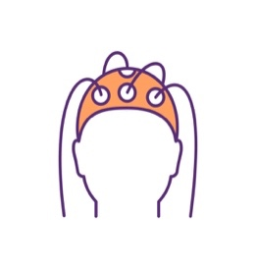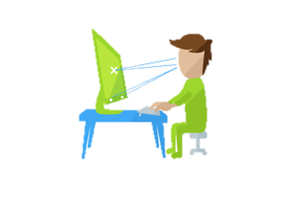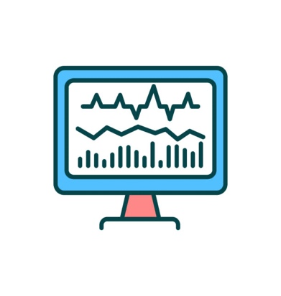

Left eye closed

Alpha waves

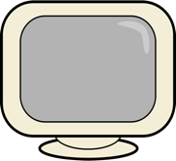

EYE

EEG

Encode

Signal Processing

Decode

ML Classification

Inference

(almost) real-time

**Checkpoint 1**: Getting familiarize with the recording equipment – the gear is already setup and running in the EEG room. Here we would like you both to get a better understanding of the python packages and interfaces that will be used to collect the data.

**Checkpoint requirement** - Conduct a short recording session of EEG and Eye data with LSL python package. And comparing the recording with ground truth reference of each component. At this part of the project, you should carry out the encoding part of the system.

**Deadline**

**Checkpoint 2**: Collectingdata for decoding and ML training. Here the goal is to think of some neural and eye cues (looking left/right, closing the eyes, alpha wave gamma waves etc.) Colleting, preprocessing and labeling the time series data and then training and validating a classification algorithm based on those cues.

**Checkpoint requirement –** Collecting the data from one or two participants (this could be one of you) validating and reporting on the accuracy of the model. At this stage the system should be making inference offline. That is, the inference of the system will be on a dataset with a ground truth labels. At this stage you should carry out the decoding part of the system.

**Deadline**

**Checkpoint 3:** Developing apythonscript integrating the two checkpoints to a systemthatcould be run live during an experiment. Here the goal is to design an experiment to test the final system.

**Checkpoint requirement –** Running a live experiment with the fully trained system asking participants to execute the neural and eye cues you collected in checkpoint 2. Then the system should process the data (checkpoint 1), classify it (checkpoint 2), and disply visual stimulus according to the inference of the system. This should be run in almost real-time.

**Deadline**